# Introduction

The Marine Institute has conducted groundfish surveys to determine the distribution and abundance of commercial fish around Ireland since 1990. Historically, the surveys were carried out on commercial fishing vessels and later included small research ships. The Irish Groundfish Survey (IGFS) in its current form commenced in 2003 on the 65m research vessel, the *R.V. Celtic Explorer*.

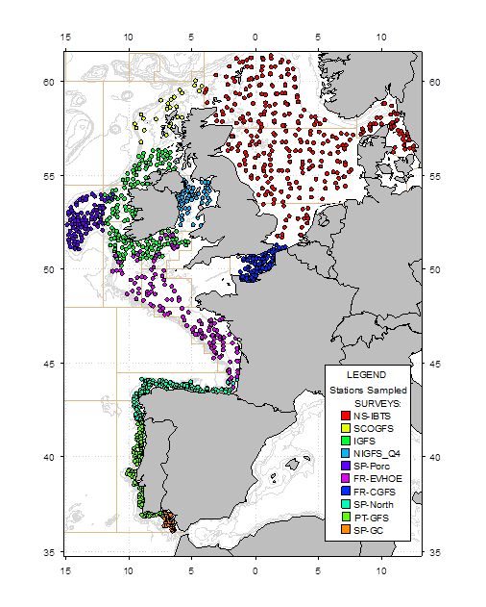

Fig 1. Map of the IGFS in the context of the other IBTS quarter 3&4 Surveys.

The IGFS forms part of a co-ordinated International Bottom Trawl Survey programme (IBTS) under the umbrella of the International Council of the Exploration of the Sea (ICES). In Irish waters currently, France and Ireland cover the Celtic Sea area, Ireland covers the shelf West of Ireland, Ireland and the UK Scotland cover the north coast of Ireland and the UK Northern Ireland covers the Irish Sea (Fig 1).

Fisheries management often relies on commercial data to estimate the quantity of fish removed from a stock annually. In contrast, scientific surveys such as the IGFS provide data for juvenile fish not typically found in commercial data in order to predict what will be replenishing the stock in the coming year(s). In addition, areas outside of commercial hotspots are also monitored.

The IGFS contributes to Ireland’s international obligation to supply scientific data that support the implementation of the Common Fisheries Policy (CFP). Data is collected under the Data Collection Framework (DCF), which is the main instrument used by the European Commission to collect scientific data for the CFP.

# Survey objectives

## Primary

The IGFS provides ICES assessment and science groups with consistent and standardised data for examining spatial and temporal changes in (a) the relative abundance and distribution of fish and fish assemblages; and (b) the biological parameters of commercial fish species, for stock assessment purposes.

The main objectives of the IGFS, as coordinated by the international bottom trawl surveys (IBTS), are:

1. To determine the relative abundance and distribution of pre-recruits for the main commercial species and provide recruitment indices;
2. To monitor changes in the stocks of commercial fish species independently of commercial fisheries data;
3. To monitor the distribution and relative abundance of all fish species and selected invertebrates;
4. To collect data for the determination of biological parameters for selected species.

## Ancillary

To maximise the utility of work aboard a national marine research platform such as the *RV* *Explorer* however, a number of ancillary objectives are also undertaken:

1. To collect hydrographical information on the water column and the seafloor;
2. To collect information on the composition and quantities of litter items on the sea floor, as caught in the fish trawl;
3. To collect data on fish biology, invertebrates and or/the environment as specified by additional requests from international institutions and universities and as regarded practicable during the course of the survey.

# Survey design

## Station allocation

Much of the seabed is not flat or of soft sediment type (figure 2a) and thus not trawlable (see figure 2b). Within trawlable areas the availability of fish varies as does a trawl’s ability to capture fish due to various technical, biological and environmental factors. Not every fish in the path of a trawl therefore will be captured and sampling design in IBTS surveys is underpinned by a strong emphasis on standardised sampling trawls and procedures. This helps ensure that changes in annual abundance seen in the catch data reflect a relative change in population abundance rather than a change in the trawl’s ability to sample the population.

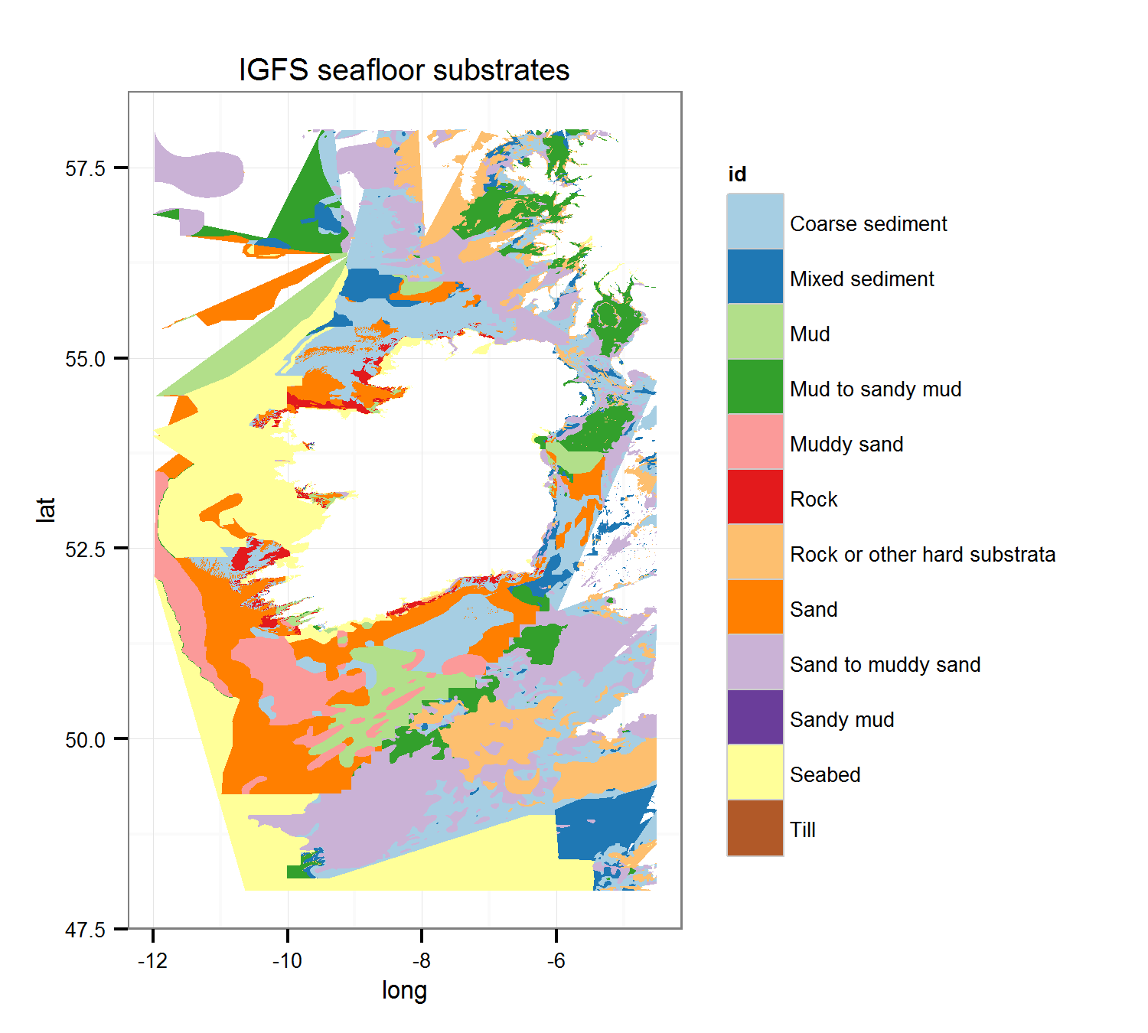

Fig. 2a Map of seafloor substrates around Ireland, based on collated seafloor habitat data as compiled by MESH Atlantic (see www.meshatlantic.eu)

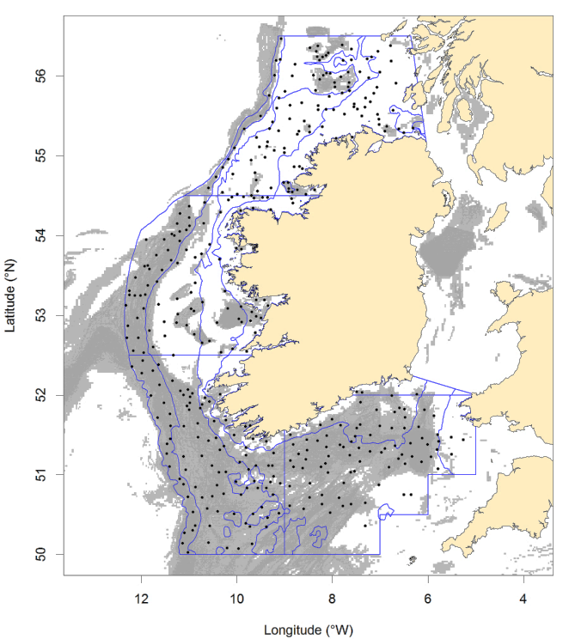

Fig. 2b Map of IGFS historic haul positions (black circles) in relation to commercial otter trawl activity (grey shaded area). Darker shading equates to higher commercial fishing intensity whilst little or no commercial activity can broadly be interpreted as challenging ground for demersal trawling.

The IGFS uses a semi-random depth stratified survey design. Potentially any trawlable ground within the survey area therefore should be sampled at some point and avoids artificially stable catch rates from persistent local hot/cold spots. In as far as is practicable, a minimum of 10 nautical miles is maintained between hauls to avoid repeat sampling of the same fish assemblage.

Stations are stratified according to ICES divisions (management units) as well as depth bands, culminating in 15 strata in total (Figure 3). Depth boundaries are 0-80m, 81-120m, 121-200m, 201-600m corresponding to Coastal, Medium, Deep and Slope respectively. Haul allocation per strata is proportional to the area. In total 170 stations are allocated annually at random from historical survey tow positions. The database of potential survey tows is also continually expanded whenever possible with new information from commercial and research fishing activity as well as multibeam data, all of which provides the important additional random element to the design.

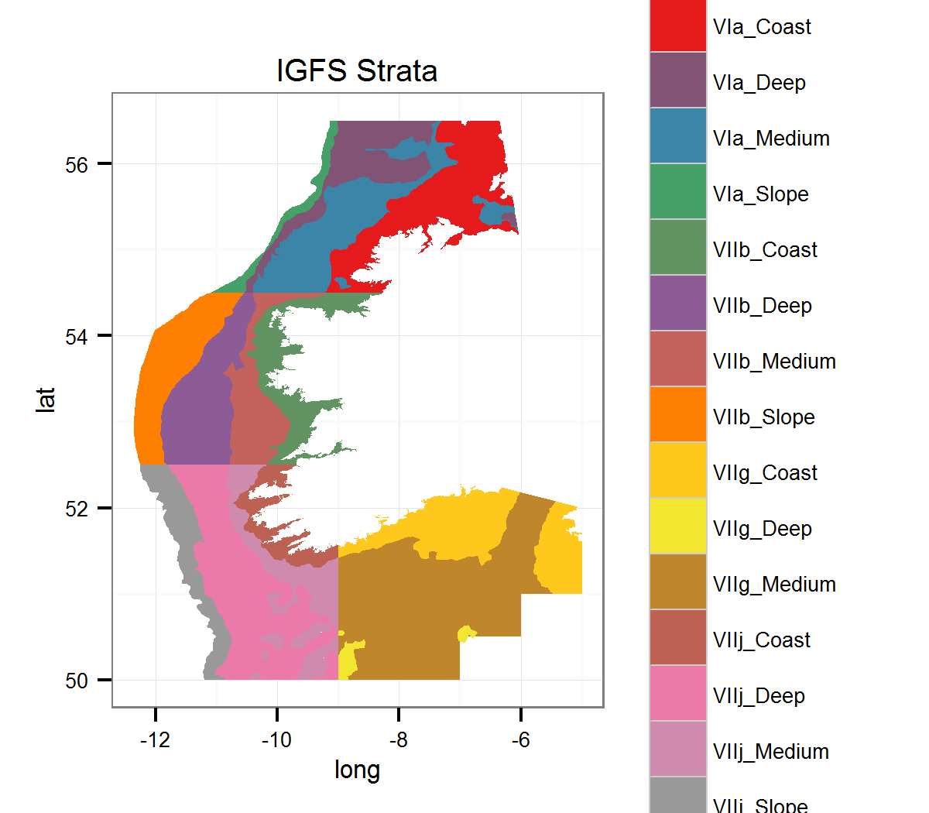

Fig. 3 Map of IGFS survey strata. Coastal strata = 0-80m; Medium strata = 81m-120m; Deep strata = 121m-200m; Slope strata = 201m-600m.

## Sample allocation

Given that reproduction and recruitment of juveniles into the adult stock is seasonal in temperate waters, management of many commercially exploited fish stocks is based on numbers at age. Ageing fish is labour intensive relative to measuring lengths and therefore length frequency sampling carried out on survey is later allocated to age groups, where appropriate, based on smaller biological samples returned to the laboratory for ageing.

Up until 2007, targets for age samples were set on a length-stratified basis for each stratum. Generally this meant that no more than 5 individuals per 1cm size class per stratum would be sampled. However, this type of quota-sampling can introduce bias if the age structure within a stratum is not uniform. For example, it is possible that at a length of, say 20cm, 80% of fish are age 2 and 20% are age 3 on an inshore station, while on a station further offshore (within the same stratum) those proportions are 60% / 40%. With the old “quota-based" sampling, the samples are not equally spread out between hauls and this can be the source of bias. Therefore, sampling targets were set for each station (rather than each stratum) from 2008 onwards. In practice, this meant a sampling target of 1 fish per cm size class for each station. For species that have abundant catches of young fish that are likely to be all the same age, the size classes can be broadened, e.g. 1 fish per 5cm per station. For fish that are rare in the catches (e.g. cod), the targets will often be set to sample all fish, even if there are more than one per size class.

# Methodology

## Technical description of the hauls

The trawl is towed for 30min at 4 knots ensuring good consistent contact with the seabed and a minimum headline height of 3.5m. All fish and commercial shellfish are sorted to species level prior to taking lengths and other biological measurements such as age, sex and maturity. Where species are abundant all or parts of the length frequency will be sub-sampled to ensure the final raised data is a true reflection of the length frequency of the catch. Weights and measurements are entered directly into an electronic measuring system in the fish-room with biological targets being flagged and met during this routine length frequency sampling.

## Vessel and gear

The IGFS is carried out on board the R/V *Celtic Explorer*, a 65 m vessel with 4320 KW engine power. The trawl used is a high headline “*Grande Overture Verticale*” (GOV 36/47), as is used throughout much of the shallow NE Atlantic shelf and North Sea areas within IBTS (See Figure 4). A nylon 20mm liner is used in the cod-end to retain juvenile fish. In line with IBTS recommendations, sweeps are lengthened to maintain trawl geometry in deeper water, from 55m up to depths of 80m to 110m in deeper water.

Due to the generally harder and more difficult trawling grounds off the northwest coast all hauls in Area VIa of the survey are carried out using a GOV rigged with 16”” hoppers to minimise gear damage (Fig 5). The remaining survey is completed using GOV’s in their more traditional A-gear configuration (8” disks centre).



Figure 4. Net panels for the GOV 36/47 trawl gear used on the IGFS survey

GOV36_47

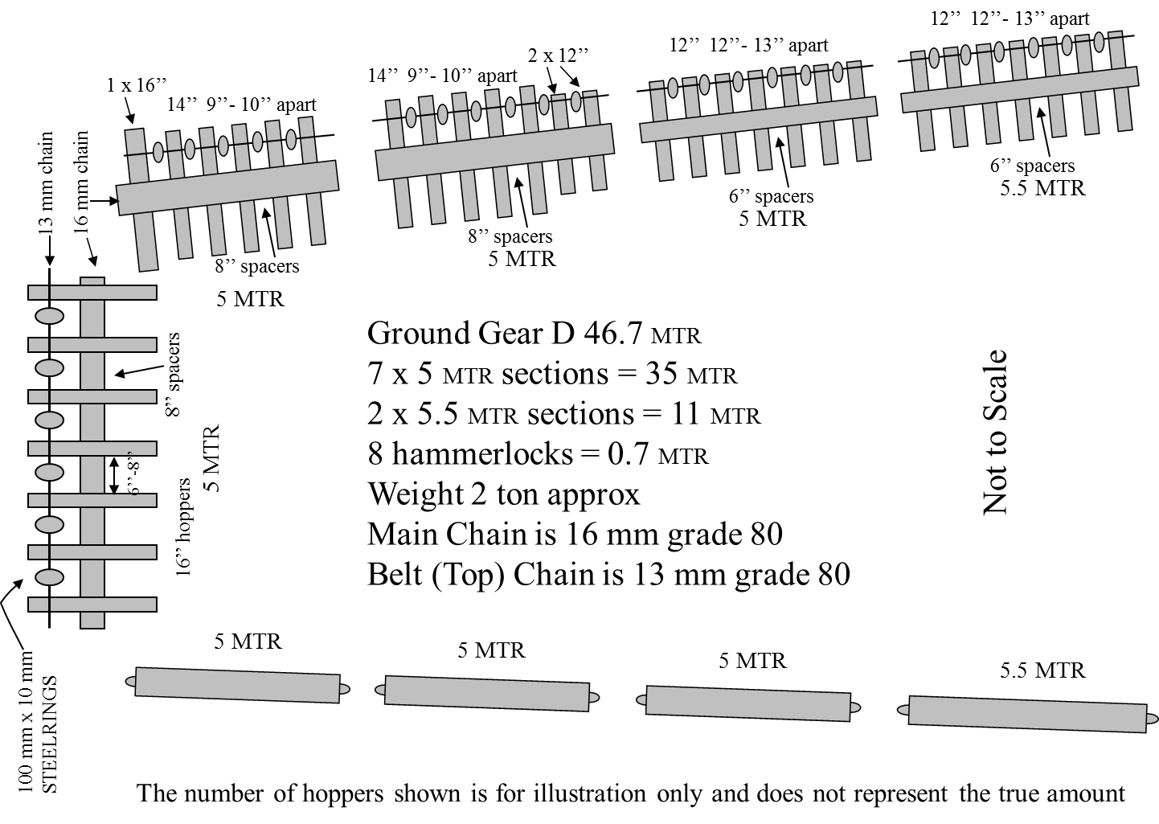

Figure 5 Standard A-type groundrope for the 36/47 GOV trawl groundgear ‘A’ top and groundgear D below.

## Data QA and storage

All catch data for each haul is entered directly into Access databases via electronic measuring boards. A range of automated quality checks are run in the fish room after each haul to capture any erroneous records as early as possible.

Quality checked catch data for the day is then loaded on to a central secure server running SQLServer 2010. This survey database also contains the other positional and gear parameter meta-data for the tows. Raw navigation and gear monitoring information is also logged directly into SQLServer.

## Additional sampling undertaken

#### CTD sampling

A HydroBios CTD is attached to the starboard trawl door for each fishing tow. This instrument collects Conductivity (analogous to salinity), Temperature and Depth information during the fishing tow which is subsequently downloaded on a daily basis and stored on a central server.

#### Oceanographic sampling for the CaNDyFloSS project

The UK NERC funded CANDYFLOSS project is a work-package of the substantial Shelf Sea Biogeochemistry programme (SSB). For this project seawater samples were taken at 6 metres below the surface with the ship’s CTD rosette once a day during the duration of the survey. The three parameters of interest were Nutrients, Dissolved Inorganic Carbon and Dissolved Organic Matter. The aim of the sampling was to look at fluxes of carbon dioxide into and out of the NW European shelf seas and at air-sea exchange. Partner organisations include the University of Liverpool, the UK MET Office, University of Bergen, Norway; the University of California as well as partners in Spain, Germany, Denmark, Scotland and France.

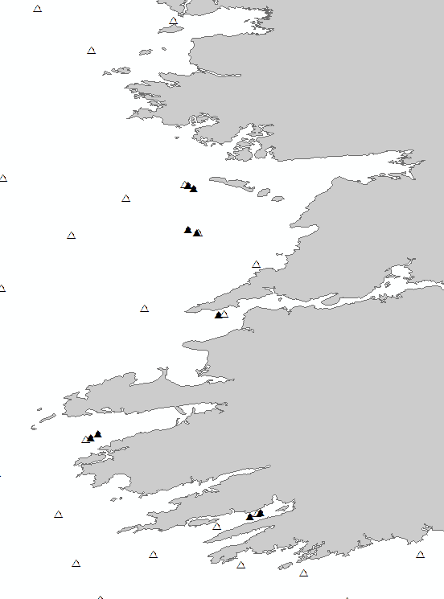

**Fig. 6 Locations of beam trawl (black triangle) and GOV (white triangle) comparison hauls on the South west coast of Ireland.**

#### Oceanographic transects

Three dedicated CTD transects are also carried out annually. These are located off the Northwest, Southwest and Southeast coasts to collect data on shelf currents. With the ship stationary the CTD rosette is lowered to just above the seabed before retrieval providing real time data of the vertical temperature and salinity profile. Sampling is repeated along these transects at 6 nautical mile intervals to provide data for spatial modelling of oceanographic currents.

#### Collection of benthic invertebrates by beam trawl

As part of an internal review the inter-annual variability of the benthic component of the catch was reviewed. Being more suited for targeted benthic sampling a small beam trawl was used to compare directly the benthic species diversity within the GOV versus parallel tows using a beam trawl at selected locations (Fig. 6).

The invertebrate macro-fauna has routinely been recorded throughout the groundfish time series to the extent that resources and staff experience allow. The protocol involves sorting to as near species level as is practical prior to recording weights. In addition, for 2014, recording a count of individuals was trialled and will be evaluated prior to inclusion hereafter.

In order to review specific animal groups causing taxonomic identification problems between survey legs and years, a number of samples were sent externally to the Marine Institute for independent expert validation.

#### Seabass

Seabass sampling was carried out in the Celtic sea to assist with an M.Sc. programme. The work involved attaching of Floy tags to anaesthetised adult fish prior to releasing them back to sea. The data will be used to investigate stock distribution and migratory patterns in the Celtic Sea.

#### Mackerel

A number of juvenile mackerel, between 15 and 22cm in length, were collected and frozen for subsequent stomach analysis by the Danish National Institute of Aquatic Resources.

#### Sprat & Herring

A number of sprat and herring samples were collected for a Ph. D. study. The aim of the project is to describe the population structure, ecology and stock identity of *Sprattus sprattus* within the Celtic Sea Eco-Region. Sampling involved freezing >300g samples of sprat and >100g samples of herring from as many stations as possible.

#### Sepiolids

All sepiolids were identified, counted and stored in alcohol. The samples are subsequently sent to the National Museum of Natural History in the Netherlands annually for formal identification as part of an ongoing sample request.

#### Elasmobranchs

Genetic fin clip samples were collected from *Raja clavata* and stored in alcohol for a French study.

Various elasmobranchs such as Common Skate, Tope, Blue shark, Smooth Hound, Porbeagle and large Spurdog were tagged on an opportunistic basis using Jumbo rototags. Fish in good condition were quickly removed for measurement, tagging and release. Post survey, the tag data was sent to Inland Fisheries Ireland who manage the programme.

Egg cases for *Leucoraja circularis* and any skate species were identified but not retained.

A request was made to collect fin clip samples from any Blue shark encountered, however none were found.

#### Litter

All litter collected during trawl hauls is recorded by type, weight and volume. The litter categories are those agreed on by the IBTS Working Group.

#### Seapens

Seapens from any hauls were collected for the UK Natural History Museum. The samples were frozen whole with the objective being to carry out population genetic analysis using microsatellite markers.